Backend Schema
  - Chorus: Multi-Output Synchronised Audio Hub
Contents

Field | Value
Document | Backend / Data Schema
Product | Chorus: Multi-Output Synchronised Audio Hub
Schema version | 1
Version | 0.1.0 (Draft)
Last updated | 2026-08-25
Companion documents | PRD · TRD · UI Flow · User Manual

1. Storage Model
Chorus has no database. State is a small number of human-readable JSON files, because the configuration is small, must be hand-editable (NFR-5), and benefits from being version-controllable by the user.
%APPDATA%\Chorus\
├── chorus.json # desired state. The single source of truth
├── profiles\
│ ├── living-room.json # calibration profile
│ └── bedroom.json
├── logs\
│ ├── chorus.log # rolling application log
│ └── calibration-<ts>.json # immutable measurement record per run
└── cache\
└── devices.json # last-seen device inventory (regenerable)
Property | Rule
Authority | chorus.json is desired state. The audio engine holds actual state. They are reconciled at startup and after every engine restart.
Regenerability | Anything under cache\ may be deleted safely.
Immutability | Calibration run records are append-only and never rewritten.
Encoding | UTF-8 without BOM, LF line endings, two-space indent.
Secrets | None. No file contains credentials; the whole tree is safe to attach to a bug report.

2. Entity Model
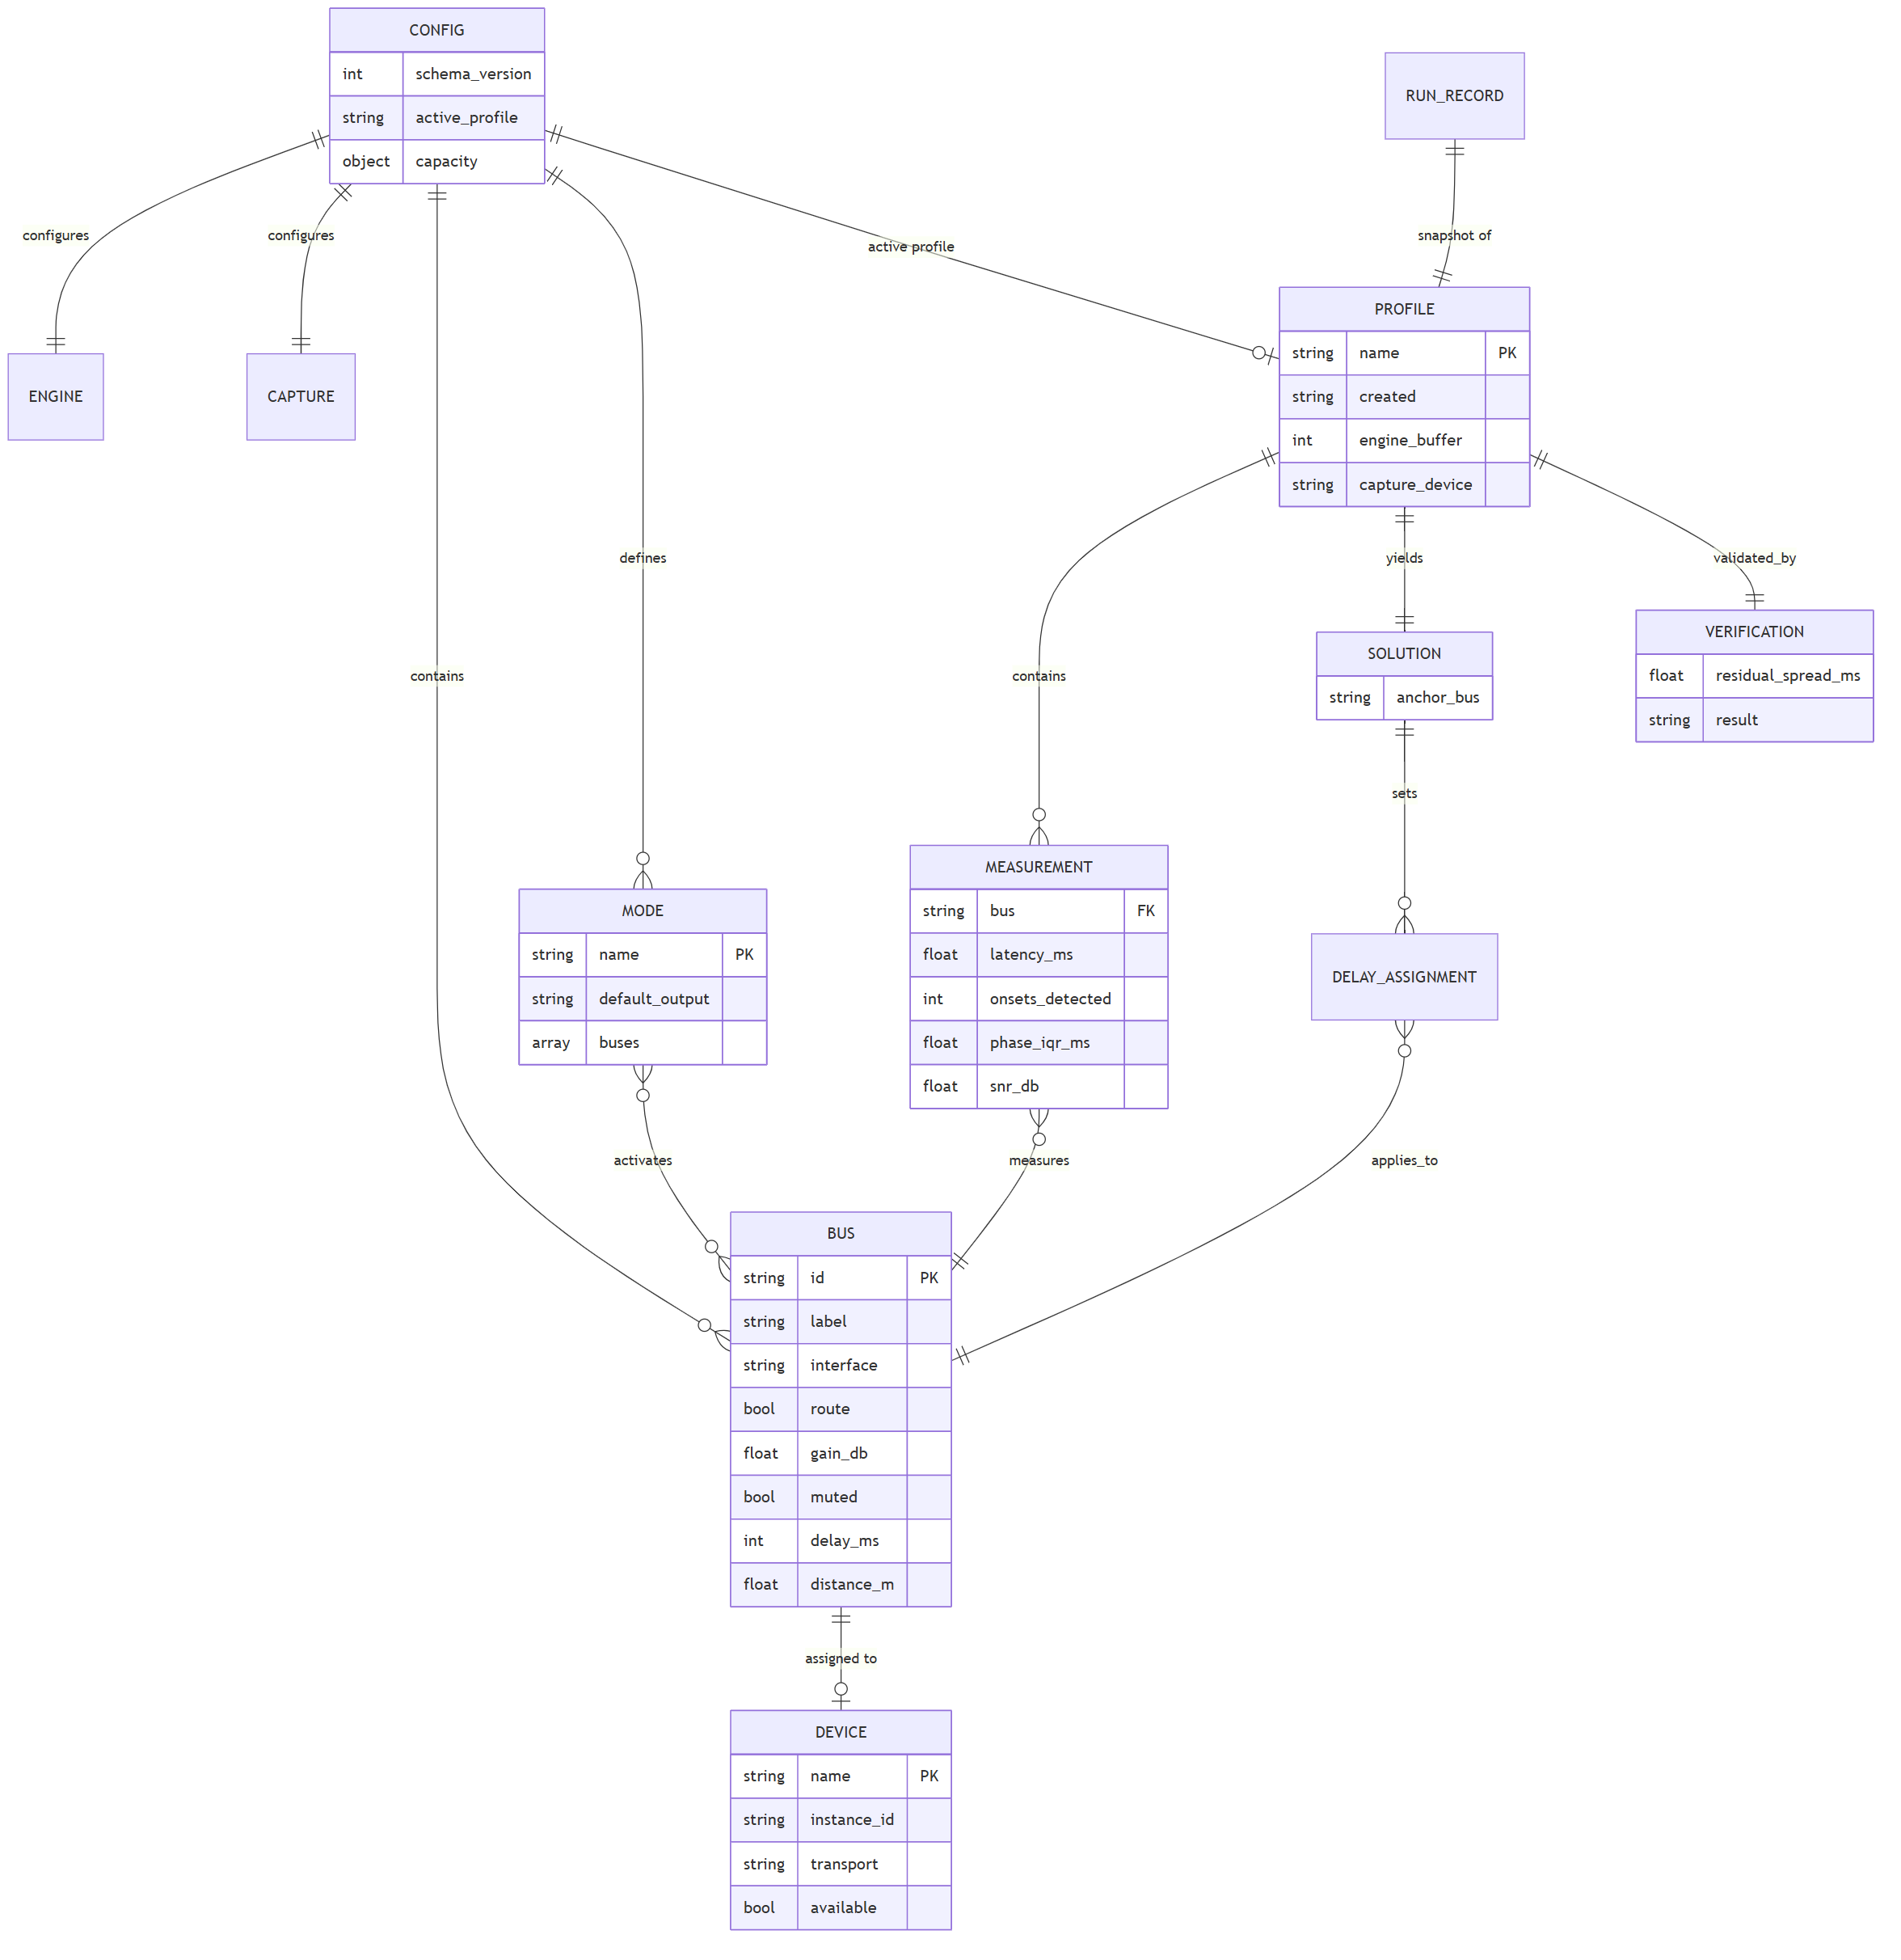
Figure 1. Entity Model

3. chorus.json: Main Configuration

3.1 Example
{
"schema_version": 1,
"engine": {
"backend": "voicemeeter-potato",
"preferred_interface": "mme",
"buffers": { "wdm": 1024, "mme": 2048, "ks": 512 },
"autostart": true,
"restart_settle_ms": 4000
},
"capture": {
"device": "Microphone (Realtek High Definition Audio)",
"sample_rate": 22050,
"channels": 1,
"gain_policy": "manual"
},
"capacity": {
"bluetooth_a2dp_measured_max": 2,
"measured_on": "Intel Dual Band Wireless-AC 8260",
"measured_date": "2026-08-25",
"warn_above": 2,
"block_above": null
},
"buses": [
{
"id": "A1",
"label": "PartyPal 185",
"device": {
"name": "Headphones (PartyPal 185 Stereo)",
"instance_id": "BTHENUM\\{0000110B-0000-1000-8000-00805F9B34FB}_LOCALMFG&0002\\7&1a2b3c4d&0&AABBCCDDEE01_C00000000",
"transport": "bluetooth-a2dp"
},
"interface": "mme",
"route": true,
"gain_db": -12.0,
"muted": false,
"delay_ms": 42,
"distance_m": 2.0
},
{
"id": "A2",
"label": "Stone 1400",
"device": {
"name": "Headphones (boAt Stone 1400 Stereo)",
"instance_id": "BTHENUM\\{0000110B-0000-1000-8000-00805F9B34FB}_VID&0002099A_PID&0500\\7&1a2b3c4d&0&AABBCCDDEE02_C00000000",
"transport": "bluetooth-a2dp"
},
"interface": "mme",
"route": true,
"gain_db": -3.0,
"muted": false,
"delay_ms": 0,
"distance_m": 2.0
},
{
"id": "A3",
"label": "Tab S9 FE+",
"device": {
"name": "Digital Output (Abhishek's Tab S9 FE+)",
"instance_id": "SWD\\WIFIDIRECT\\AA:BB:CC:DD:EE:03#MIRACAST",
"transport": "miracast"
},
"interface": "wdm",
"route": false,
"gain_db": -8.0,
"muted": false,
"delay_ms": 0,
"distance_m": 3.0
}
],
"modes": [
{
"name": "theatre",
"description": "All speakers through the hub",
"default_output": "__virtual__",
"buses": ["A1", "A2"]
},
{
"name": "partypal",
"description": "PartyPal only, engine bypassed",
"default_output": "Headphones (PartyPal 185 Stereo)",
"buses": []
},
{
"name": "laptop",
"description": "Built-in speakers",
"default_output": "Speakers (Realtek High Definition Audio)",
"buses": []
}
],
"active_profile": "living-room",
"startup": {
"restore_mode": "theatre",
"verify_assignments": true,
"max_wait_for_engine_s": 60
}
}

3.2 Field reference

engine
Field | Type | Required | Default | Notes
backend | enum | yes | voicemeeter-potato | Future: pipewire
preferred_interface | enum | yes | wdm | wdm | mme | ks. mme buffers deeper, better dropout tolerance, more latency (TRD §3.3)
buffers | object | no | see below | Per-interface buffer size in samples
buffers.<iface> | int | no | 1024 | Allowed: 128-2048, power of two
autostart | bool | no | true | Launch engine with the host
restart_settle_ms | int | no | 4000 | Wait after engine restart before re-asserting assignments (TRD D3)

capture
Field | Type | Required | Default | Notes
device | string | yes | n/a | Windows friendly name of the calibration microphone
sample_rate | int | no | 22050 | 22.05 kHz gives 45 µs resolution, ample for a 1 ms target
channels | int | no | 1 | Mono only
gain_policy | enum | no | manual | manual | auto. auto reserved for a future AGC pass

capacity
Encodes the measured transport ceiling so warnings cite a real number (TRD §4.1, F9).
Field | Type | Required | Notes
bluetooth_a2dp_measured_max | int | null | yes | null means "not yet measured on this host", the UI must then say so rather than invent a figure
measured_on | string | no | Adapter name the figure was measured against
measured_date | date | no | ISO 8601
warn_above | int | null | no | Warn when assigned A2DP outputs exceed this
block_above | int | null | no | Hard refusal threshold. null = never block, only warn
block_above defaults to null deliberately: the user owns their hardware, and a project whose central open question is "how many actually work?" must let people exceed the current figure and report back.

buses[]
Field | Type | Required | Constraints | Notes
id | string | yes | A1-A5 | Engine bus identifier
label | string | yes | 1-40 chars | Display name
device | object | null | yes | n/a | null = unassigned
device.name | string | yes | n/a | OS friendly name; used for assignment
device.instance_id | string | yes | n/a | Stable identity; used for transport detection and re-matching
device.transport | enum | yes | see §4 | Derived from instance_id, never from the name
interface | enum | yes | wdm|mme|ks | Driver interface for this bus
route | bool | yes | n/a | Source routed to this bus
gain_db | float | yes | −60.0 … +12.0 | Engine range; UI exposes −40 … +6
muted | bool | yes | n/a | Independent of gain
delay_ms | int | yes | 0 … 500 | Applied delay; engine restart required to take effect
distance_m | float | no | 0.1 … 20.0 | Microphone distance for calibration correction (FR-2.8)

modes[]
Field | Type | Required | Notes
name | string | yes | Unique, lowercase, no spaces
description | string | no | Shown in the tray submenu
default_output | string | yes | OS device name, or the sentinel __virtual__ to route through the engine
buses | array<string> | yes | Bus IDs to enable. Empty for engine-bypass modes
The __virtual__ sentinel distinguishes hub modes from direct modes. Direct modes point the OS default straight at one device so they work even when the engine is not running, which is exactly what a user needs when they want one speaker and nothing else.

4. Transport Enumeration
device.transport is derived from the instance path (TRD §4.3), never from the friendly name.
Value | Instance-path pattern | Assignable
bluetooth-a2dp | BTHENUM\{0000110B-...} | Yes
bluetooth-hfp | BTHENUM\{0000111E-...}, BTHHFENUM\ | No, mono, ~8 kHz, excluded from output selection
miracast | SWD\WIFIDIRECT\...#MIRACAST | Yes
hdmi | Display-audio driver interface | Yes
analog | Onboard codec interface | Yes
virtual | Engine's own virtual endpoints | Internal use only
unknown | No pattern matched | Yes, with a warning
Excluding bluetooth-hfp from the assignable list is a functional requirement, not a nicety: those endpoints appear alongside the good ones with near-identical names, and selecting one silently degrades the speaker to telephone quality.

5. Calibration Profile
Stored at profiles\<name>.json. Written only on a passing or marginal verification.
{
"schema_version": 1,
"name": "living-room",
"created": "2026-08-25T18:04:22+05:30",
"host": {
"engine": "voicemeeter-potato 3.1.2.2",
"engine_buffer": 2048,
"engine_interface": "mme",
"adapter": "Intel Dual Band Wireless-AC 8260"
},
"capture": {
"device": "Microphone (Realtek High Definition Audio)",
"sample_rate": 22050
},
"stimulus": {
"waveform": "sine-burst",
"frequency_hz": 1000,
"burst_ms": 8,
"envelope": "linear-decay",
"period_ms": 700,
"periods_per_output": 8,
"peak_dbfs": -6.0
},
"measurements": [
{
"bus": "A1",
"device_name": "Headphones (PartyPal 185 Stereo)",
"transport": "bluetooth-a2dp",
"onsets_expected": 8,
"onsets_detected": 8,
"phase_median_ms": 176.4,
"phase_iqr_ms": 3.5,
"snr_db": 22.4,
"distance_m": 2.0,
"distance_correction_ms": 5.8,
"latency_ms": 170.6,
"quality": "good"
},
{
"bus": "A2",
"device_name": "Headphones (boAt Stone 1400 Stereo)",
"transport": "bluetooth-a2dp",
"onsets_expected": 8,
"onsets_detected": 8,
"phase_median_ms": 218.4,
"phase_iqr_ms": 4.1,
"snr_db": 19.8,
"distance_m": 2.0,
"distance_correction_ms": 5.8,
"latency_ms": 212.6,
"quality": "good"
}
],
"solution": {
"anchor_bus": "A2",
"anchor_latency_ms": 212.6,
"delays": { "A1": 42, "A2": 0 }
},
"verification": {
"performed": true,
"residual_spread_ms": 6.0,
"threshold_ms": 10.0,
"result": "pass",
"per_bus_latency_ms": { "A1": 212.6, "A2": 218.6 }
}
}

5.1 Measurement fields
Field | Type | Notes
onsets_expected / onsets_detected | int | A shortfall indicates dropped packets or a weak signal
phase_median_ms | float | Median onset phase modulo the stimulus period (TRD §6.4)
phase_iqr_ms | float | Inter-quartile range, the transport-stability figure
snr_db | float | Stimulus peak over noise floor
distance_correction_ms | float | distance_m / 343 × 1000, subtracted from phase
latency_ms | float | Distance-corrected latency; the value the solver uses
quality | enum | good | marginal | unusable, from the rules below

5.2 Quality classification
Quality | Conditions (all must hold)
good | onsets_detected == onsets_expected, phase_iqr_ms ≤ 8, snr_db ≥ 12
marginal | onsets_detected ≥ 0.75 × expected, phase_iqr_ms ≤ 20, snr_db ≥ 6
unusable | Anything else, excluded from the solution and reported to the user

5.3 Verification results
result | Condition | Profile persisted?
pass | residual_spread_ms ≤ threshold_ms | Yes
marginal | threshold_ms < spread ≤ 2.5 × threshold_ms | Yes, with warning
fail | spread > 2.5 × threshold_ms, or any output unusable | No
A failed run still writes an immutable record to logs\calibration-<ts>.json, but must not modify chorus.json. Partial application is the worst outcome: it leaves the system less synchronised than before while appearing configured.

6. Device Cache
cache\devices.json, regenerable, non-authoritative.
{
"schema_version": 1,
"scanned": "2026-08-25T18:00:11+05:30",
"devices": [
{
"name": "Headphones (PartyPal 185 Stereo)",
"instance_id": "BTHENUM\\{0000110B-...}",
"transport": "bluetooth-a2dp",
"state": "active",
"available": true,
"last_seen": "2026-08-25T18:00:11+05:30"
},
{
"name": "Headset (PartyPal 185 Hands-Free AG Audio)",
"instance_id": "BTHHFENUM\\BTHHFPAUDIO\\...",
"transport": "bluetooth-hfp",
"state": "active",
"available": true,
"assignable": false,
"excluded_reason": "hands-free profile, mono, low bandwidth"
}
]
}
Retaining excluded devices with an explicit reason lets the UI explain why a device the user can see in Windows does not appear in the assignable list.

7. Validation Rules
Enforced by chorus config validate and on every load.
ID | Rule | Severity
V-1 | schema_version is known and ≤ current | Error
V-2 | Bus id values are unique and within A1-A5 | Error
V-3 | No two buses reference the same device.instance_id | Error
V-4 | gain_db within −60 … +12 | Error
V-5 | delay_ms integer within 0 … 500 | Error
V-6 | Buffer sizes are powers of two within 128 … 2048 | Error
V-7 | Every modes[].buses[] entry references an existing bus | Error
V-8 | Mode names are unique | Error
V-9 | active_profile names an existing profile file, or is null | Warning
V-10 | No assigned device has transport == "bluetooth-hfp" | Error
V-11 | Count of routed bluetooth-a2dp buses ≤ capacity.warn_above | Warning
V-12 | At least one bus is routed in the mode named by startup.restore_mode | Warning
V-13 | distance_m present on all buses, or absent on all | Warning
V-13 exists because mixing declared and undeclared distances silently biases the solution. The correction would be applied to some outputs and not others.

8. Startup Reconciliation
Desired state (chorus.json) is reconciled against actual engine state at every startup and after every engine restart.
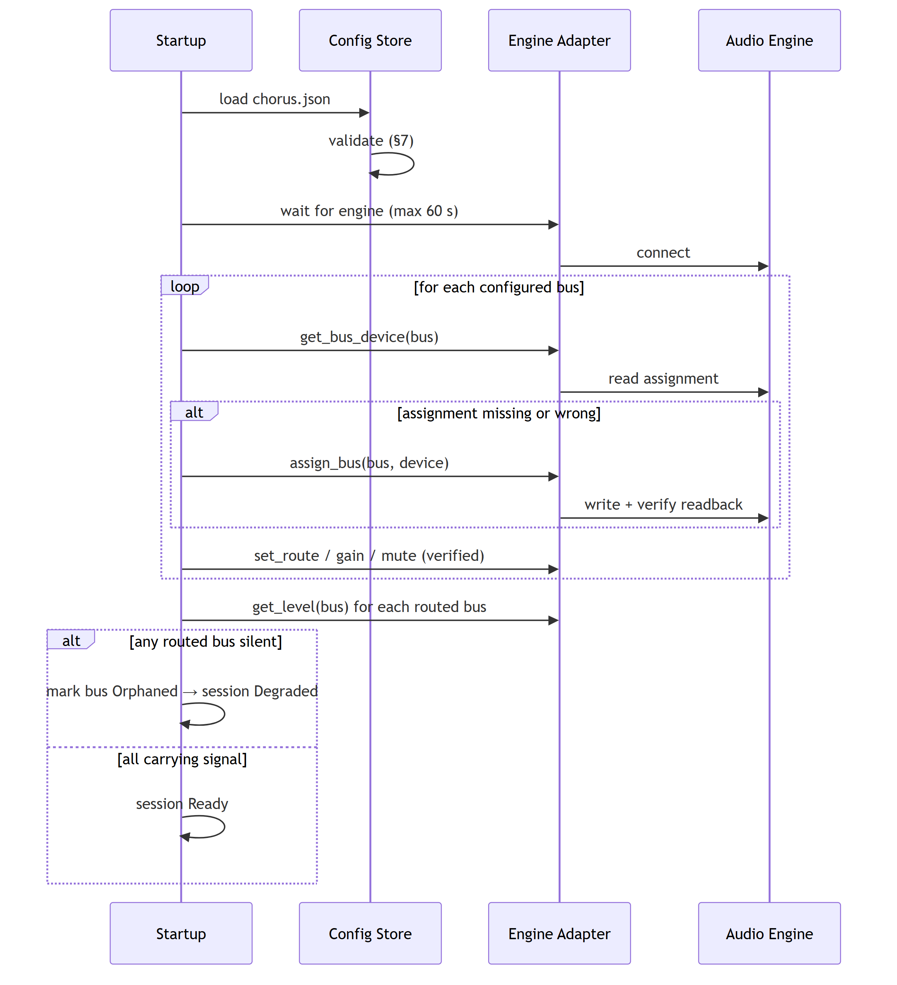
Figure 2. Startup Reconciliation
The per-bus verification loop is not defensive over-engineering: on the reference platform, engine restarts drop assignments silently (TRD D3), so unconditional re-assertion is the only reliable path to a known-good state.

9. Logging

9.1 Application log
Rolling, 5 files × 1 MB, plain text:
2026-08-25T18:04:22+05:30 INFO engine connected: Voicemeeter Potato 3.1.2.2
2026-08-25T18:04:23+05:30 WARN bus.A3 device not found: Digital Output (Abhishek's Tab S9 FE+)
2026-08-25T18:04:23+05:30 INFO session state=Degraded (2 of 3 outputs active)
2026-08-25T18:05:02+05:30 INFO calib run started, profile=living-room, outputs=2
2026-08-25T18:05:41+05:30 INFO calib A1 latency=170.6ms iqr=3.5ms snr=22.4dB quality=good
2026-08-25T18:06:19+05:30 INFO calib A2 latency=212.6ms iqr=4.1ms snr=19.8dB quality=good
2026-08-25T18:06:20+05:30 INFO calib solution anchor=A2 delays={A1:42,A2:0}
2026-08-25T18:06:31+05:30 INFO calib verification spread=6.0ms result=pass

9.2 Calibration run records
One immutable JSON file per run at logs\calibration-<ISO8601>.json, containing the full profile structure (§5) plus result even when failed. These accumulate into the dataset that answers the project's central open question, how many outputs a given adapter really sustains, and how latency varies by device and codec.

10. Schema Evolution
Rule | Detail
Version field | Every file carries schema_version
Compatibility | A newer Chorus reads older configs; an older Chorus refuses a newer schema_version with a clear message rather than misparsing
Migration | On load, migrations run in sequence v(n) → v(n+1); the pre-migration file is copied to chorus.json.bak-v<n>
Additive changes | New optional fields with defaults do not bump the version
Breaking changes | Renames, removals, or semantic changes bump the version and require a migration

10.1 Planned migrations
From → To | Change | Migration
1 → 2 | Per-output EQ (PRD W-3, deferred) | Add buses[].eq defaulting to bypass
1 → 2 | Network outputs (PRD N3) | Add transport: "vban", extend device with endpoint fields

11. JSON Schema (excerpt)
Published at schema/chorus.schema.json for editor validation.
{
"$schema": "http://json-schema.org/draft-07/schema#",
"title": "Chorus Configuration",
"type": "object",
"required": ["schema_version", "engine", "buses"],
"properties": {
"schema_version": { "type": "integer", "minimum": 1, "maximum": 1 },
"engine": {
"type": "object",
"required": ["backend", "preferred_interface"],
"properties": {
"backend": { "enum": ["voicemeeter-potato", "pipewire"] },
"preferred_interface": { "enum": ["wdm", "mme", "ks"] },
"buffers": {
"type": "object",
"additionalProperties": {
"type": "integer",
"enum": [128, 256, 512, 1024, 2048]
}
},
"autostart": { "type": "boolean" },
"restart_settle_ms": { "type": "integer", "minimum": 0, "maximum": 30000 }
}
},
"buses": {
"type": "array",
"maxItems": 5,
"items": {
"type": "object",
"required": ["id", "label", "device", "interface", "route", "gain_db", "muted", "delay_ms"],
"properties": {
"id": { "enum": ["A1", "A2", "A3", "A4", "A5"] },
"label": { "type": "string", "minLength": 1, "maxLength": 40 },
"device": {
"oneOf": [
{ "type": "null" },
{
"type": "object",
"required": ["name", "instance_id", "transport"],
"properties": {
"name": { "type": "string" },
"instance_id": { "type": "string" },
"transport": {
"enum": ["bluetooth-a2dp", "bluetooth-hfp", "miracast",
"hdmi", "analog", "virtual", "unknown"]
}
}
}
]
},
"interface": { "enum": ["wdm", "mme", "ks"] },
"route": { "type": "boolean" },
"gain_db": { "type": "number", "minimum": -60, "maximum": 12 },
"muted": { "type": "boolean" },
"delay_ms": { "type": "integer", "minimum": 0, "maximum": 500 },
"distance_m": { "type": "number", "minimum": 0.1, "maximum": 20 }
}
}
}
}
}

